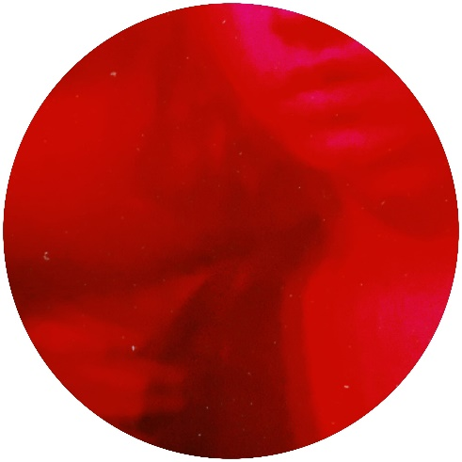
Bostock
I’m Good, on Paper
Self-Release - AWAL
Releasing : 28th May, 2021

“Neverland” is the among the first music he’s shared and is an inventive dub groover that begs to be played on a big soundsystem.” – XLR8R (Neverland)
“Massive Jackin, Dubby package” – Carmelo Carone (Remembrall / Midnight Sinner)

After gaining over 30000 streams and International radio support from the likes of Reprezent and Kiss FM AU on his previous release “Remembrall/Midnight Sinner, Bostock’s upcoming 3 track project “I’m Good, On Paper” is an experimental representation of his recent experience with grief, the high’s and lows: and what the soul craves in response. Exploring the leftfield with Deep and Dub elements that verge on electronica: yet all contain his signature UK Bass influence.
Described as a “Double entendre to the current state of being that I and most of feel now, and the different moods we feel because of it,” he explains, revolving around the fact that so many people in the world may appear to be happy or healthy: but that appearances are never quite what they seem. Meant as a ode to those, stating that “it is okay to not be okay right now, and this is a representation of that. Talk to your friends and family about how you are feeling, and it is completely normal to be tempted to do things to try and make yourself feel better”.
Bostock has self-released 3 experimental and “inventive” projects so far, which have a collective 40 thousand-plus streams and have had support from the likes of XLR8R Magazine, with spotlights from the Club Map, and his music video for track “Midnight Sinner” which stars other prominent underground artists like SUMMER ALONE and Deijuvhs premiering on Big Shot Mag with track Premieres from 8day Montreal, EELF and Moskalus.
This is in addition to Previous National and International radio play from Kiss FM Australia’s Timmy Bryne, 1020.Live Citizen, and London’s Reprezent FM via Darkstepper, which showcases the best left-field new artists from around the world.
Bostock has a regular radio show on the new online outlet “Cratedigs” and has upcoming residency this summer in Camden, London UK playing alongside other underground hip-hop and electronic artists, with multiple dates at other venues to be confirmed in support.
For more information, promo requests, or to arrange an interview contact Harry at
harry@biglove.ltd , +447469721977 or bostock.info

BOSTOCK 2021 TOUR DATES
# To be confirmed

July. 2nd, 2021 – London, UK – Castles and Air Launch

July. 21st, 2021 – London, UK – Air and Electricity x BIG LOVE #

Aug. 25th, 2021 – London, UK – Camden, AnE x BIG LOVE #

Sep. 22nd, 2021 – London, UK – Camden, BIG LOVE #

###

Press Contacts:
Harry Newark /
+447469721977 / harry@biglove.ltd

Follow Bostock:
Instagram: @b.ostock
Twitter: @bostocked
Facebook: https://www.facebook.com/bostocked/

